**ASSIGNMENT MODULE 5 – NETWORK FUNDAMENTALS AND BUILDING NETWORKS**

**Section 1: Multiple Choice**

**1. What is the primary function of a router in a computer network?**  
**Answer:** c) Forwarding data packets between networks

**2. What is the purpose of DHCP (Dynamic Host Configuration Protocol) in a computer network?**  
**Answer:** d) Dynamically assigning IP addresses to devices

**3. Which network device operates at Layer 2 (Data Link Layer) of the OSI model and forwards data packets based on MAC addresses?**  
**Answer:** b) Switch

**4. Which network topology connects all devices in a linear fashion, with each device connected to a central cable or backbone?**  
**Answer:** b) Bus

**Section 2: True or False**

**1. A VLAN (Virtual Local Area Network) allows network administrators to logically segment a single physical network into multiple virtual networks, each with its own broadcast domain.**  
**Answer:** True

**2. TCP (Transmission Control Protocol) is a connectionless protocol that provides reliable, ordered, and error-checked delivery of data packets over a network.**  
**Answer:** False

**3. A firewall is a hardware or software-based security system that monitors and controls incoming and outgoing network traffic based on predetermined security rules.**  
**Answer:** True

**Section 3: Short Answer**

**1.** **Describe the steps involved in setting up a wireless network for a small office or home office (SOHO) environment.**  
**Answer:**

**✅ Steps to Set Up a SOHO Wireless Network with Static IP Addresses**

**1. Plan the IP Address Scheme**

Choose a private IP range (e.g., 192.168.1.0/24) and assign static IPs to all devices:

| **Device** | **IP Address** | **Subnet Mask** | **Default Gateway** |
| --- | --- | --- | --- |
| Router (Fa0/0) | 192.168.1.1 | 255.255.255.0 | N/A |
| PC0 | 192.168.1.10 | 255.255.255.0 | 192.168.1.1 |
| PC1 | 192.168.1.11 | 255.255.255.0 | 192.168.1.1 |
| PC2 | 192.168.1.12 | 255.255.255.0 | 192.168.1.1 |
| Laptop | 192.168.1.20 | 255.255.255.0 | 192.168.1.1 |
| Smartphone | 192.168.1.21 | 255.255.255.0 | 192.168.1.1 |
| Server | 192.168.1.30 | 255.255.255.0 | 192.168.1.1 |
| Wireless Router (LAN) | 192.168.1.2 | 255.255.255.0 | 192.168.1.1 |

**Tip:** Avoid IP conflicts—make sure each device has a unique IP address.

**2. Configure Static IPs on Devices**

**On PCs and Servers**

1. Go to **PC > Desktop > IP Configuration**
2. Select **Static**
3. Enter:
   * IP Address (e.g., 192.168.1.10)
   * Subnet Mask (255.255.255.0)
   * Default Gateway (192.168.1.1)

**On Wireless Devices (Laptop, Smartphone)**

1. Go to **Laptop/Smartphone > Config > Wireless**
2. Set SSID (e.g., “SOHO_WIFI”) to match the wireless router
3. Enter static IP, Subnet Mask, and Default Gateway under the **IP Configuration** section.

**3. Configure Wireless Router**

1. **Wireless Settings:**
   * Set **SSID** (e.g., “SOHO_WIFI”)
   * Enable **WPA2** and set a passphrase
2. **LAN Settings:**
   * Assign IP (e.g., 192.168.1.2)
   * Disable DHCP if using full static IPs
3. **WAN Port:**
   * Connect to Switch if bridging to main router or acting as secondary gateway

**4. Configure Main Router (Router0)**

1. Enter CLI or GUI settings
2. Assign static IP to Fa0/0 (e.g., 192.168.1.1)
3. (Optional) Set static routes if needed

**5. Connect All Devices Properly**

* Use Ethernet cables between:
  + PCs ↔ Switch
  + Switch ↔ Router
  + Switch ↔ Wireless Router (LAN port)
* Ensure wireless devices connect using correct **SSID + static IP settings**

**6. Test the Network**

Use **Command Prompt** on PCs:

ping 192.168.1.1 # Ping router

ping 192.168.1.11 # Ping another PC

ping 192.168.1.21 # Ping smartphone

Use Packet Tracer's **Simulation Mode** to visualize packet flows.

**7. Secure the Network**

* Change wireless router default admin login
* Enable WPA2 encryption with a strong key
* Optionally use MAC filtering or guest network

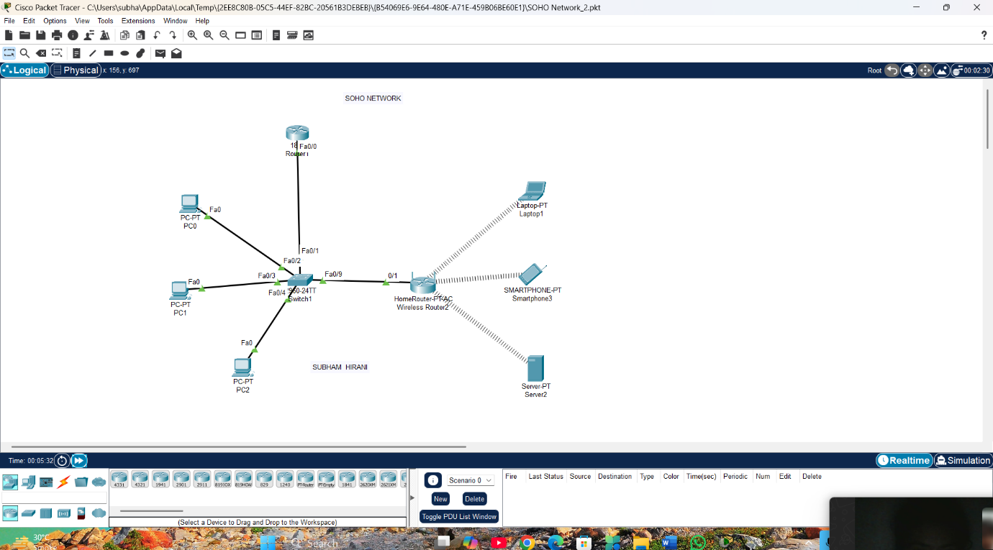

**Section 4: Practical**

**1. Demonstrate how to configure a router for Internet access using DHCP (Dynamic Host Configuration Protocol).**  
**Answer:** **A small office/home office (SOHO) network was configured using a Cisco router, a switch, and multiple end-user devices (PCs). The router's Gig0/0 interface was set to dynamically obtain an IP address from the ISP using DHCP. Network Address Translation (NAT) was configured to allow internal private IP addresses to access the Internet through the router’s public IP. The Fa0/1 interface on the router was assigned a static IP address and connected to a switch to serve as the internal gateway. A DHCP pool was created on the router to automatically assign IP addresses to the connected client devices. Functionality was verified by ensuring IP address allocation, internal connectivity, and successful external ping responses, confirming proper Internet access for all devices in the network.**

**Section 5: Essay**

**1. Discuss the importance of network documentation in the context of building and managing networks.**  
**Answer:**

**1. Importance of Network Documentation in Building and Managing Networks**

Effective network documentation is the foundation upon which robust, scalable, and secure networks are built and maintained. It encompasses a comprehensive record of network topology, device configurations, IP addressing schemes, cabling diagrams, security policies, and operational procedures. In both the design phase and day-to-day management, accurate documentation delivers the following key benefits:

**1. Accelerates Troubleshooting and Problem Resolution**

When network outages or performance degradations occur, engineers consult documentation to quickly identify affected segments, VLAN assignments, routing paths, and device roles. A clear map of switches, routers, firewalls, and their interconnections enables pinpointing root causes in minutes rather than hours. Without up-to-date records, troubleshooting often devolves into time-consuming trial and error.

**2. Ensures Consistency and Standardization**

As networks grow, consistency in naming conventions, configuration templates, and IP-address allocation is critical. Documentation enforces standards—such as device naming (e.g., R1-NYC-CORE), IP plan spreadsheets, and cabling labels—which reduces configuration drift and prevents address overlaps. Standardized configurations also simplify onboarding of new equipment or staff.

**3. Facilitates Change Management and Planning**

Introducing new VLANs, deploying additional access points, or upgrading routing protocols carries risk if changes are made blindly. Documentation provides visibility into existing dependencies (e.g., which subnets carry voice traffic vs. data), enabling impact analysis, rollback planning, and seamless integration. Moreover, version-controlled change logs record who made what change and why, improving accountability.

**4. Enhances Security and Compliance**

Regulatory requirements (e.g., PCI DSS, HIPAA) often mandate proof of network segmentation, firewall rules, and access controls. Proper documentation—firewall rule bases, VPN configurations, and user-access lists—demonstrates compliance to auditors and simplifies security audits. It also highlights any orphaned or redundant services that may pose risks.

**5. Improves Knowledge Transfer and Team Collaboration**

Network teams evolve employees join or leave, and third-party contractors may be engaged. Comprehensive “runbooks” and topology diagrams ensure that knowledge is not siloed in individual minds. New team members can quickly understand how the network is structured and how to perform routine tasks, reducing onboarding time and human error.

In summary, network documentation is not an optional administrative chore but an essential discipline. It underpins network reliability, maintainability, security, and scalability. By investing time in creating and continuously updating living documents—diagrams, IP spreadsheets, configuration archives, and operational procedures—organizations safeguard their networks against downtime, compliance failures, and knowledge loss.